Hobbies
Immersing in Classic Literature and Lore
I pair my routine of long walks with immersive audiobooks, gravitating heavily toward the intricate plotting and character studies of classic crime fiction. Authors who craft meticulous, puzzle-like narratives hold a particular appeal for me, making the brilliant detective work of Hercule Poirot and the sharp investigations of Dorothy L. Sayers' Lord Peter Wimsey frequent mainstays in my library.
Distinct from the mystery genre, The Lord of the Rings remains the absolute cornerstone of my literary interests. I am deeply invested in the expansive world-building, complex timelines, and rich lore of Middle-earth. Revisiting the series has become a dedicated annual tradition for me, particularly through the highly engaging audio performances narrated by Andy Serkis, which consistently bring a new dimension to the familiar epic.


Exploring Terrain and Waterways
Over the past two years, electric longboarding has become my preferred method for exploring new locations and covering ground. Learning to ride alongside friends and family, I have since logged over 450 miles on my Meepo V3s board. Whether navigating local routes across Florida or bringing the board along to explore the terrain of neighboring states, this pursuit offers a highly engaging, ground-level perspective of the environments I visit.
Recently, I expanded this drive for exploration from the pavement to the water by taking up paddleboarding. This allows me to navigate local coastal and inland waterways at a much different pace. A standout experience from this past year was a solo paddle out to a remote
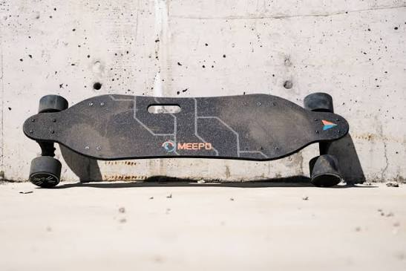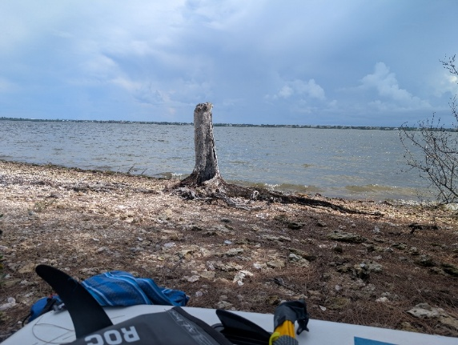

Pushing Physical Limits Through Endurance Training
Physical fitness and structured endurance training are foundational priorities in my daily routine. Currently, my athletic focus is entirely channeled toward preparing for a Spartan Race Trifecta this coming December. Spartan Races are premier global obstacle course events explicitly designed to test physical endurance, functional strength, and mental grit across incredibly rugged, unpredictable terrain.
The Trifecta amplifies this baseline challenge significantly. It requires competitors to successfully complete three distinct, increasingly demanding race formats—all within the span of a single weekend. Preparing for an event of this caliber requires a high degree of daily discipline, consistent execution in training, and the resilience to continuously push past my established physical boundaries.

